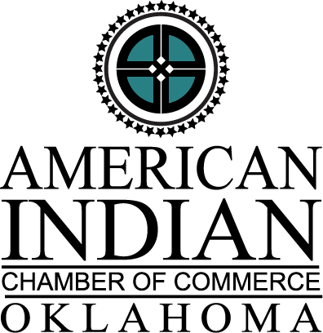

AICCO NORTH CENTRAL CHAPTER
Indigenous Collegiate Scholarship Guidelines
Application Deadline August 1, 2021

The American Indian Chamber of Commerce of Oklahoma (AICCO) North Central Chapter is a professional organization for Native American business development. Through its Scholarship Program, AICCO NC Chapter seeks to help increase the number of Native Americans achieve a higher education.

ELIGIBILITY
Candidates for the Indigenous Collegiate Scholarship must meet the following eligibility criteria:
- Applicant must possess a Certified Degree of Indian Blood (CDIB) card or Tribal I.D.
- Applicant must be attending or plan to attend an accredited college or university or vo-tech school.
- Applicant must provide a copy of their acceptance letter to receive direct scholarship funds. Funds will be distributed to school for scholarship recipients without supporting documentation.
- Applicant must provide a copy of their most recent school transcript(s) or GED.
- Applicant must be a member of one of the following ten tribes or reside in one of reservation areas of the ten tribes in Oklahoma: Tonkawa Tribe, Kaw Nation of OK, Osage Nation, Otoe-Missouria Tribe, Pawnee Nation, Muscogee Nation, Sac & Fox Nation, Kickapoo Tribe of OK, Iowa Tribe of OK, or Ponca Tribe of OK.
- Applicant must have, minimally, an overall 2.5 academic average.

SELECTION
Scholarship recipients will be determined by the organization’s committee. Recipients will receive notification of their selection and be invited to attend the North Central Chapter’s August 18, 2021, meeting to receive their award.

AWARDS
The AICCO NC Chapter will award (2) $500.00 scholarship.

Consideration will be given only to candidates submitting completed applications which include: (1) copy of their Certified Degree of Indian Blood (CDIB) or Tribal I.D.; (2) an official school transcript; (3) essay.

Completed application packages MUST BE POSTMARKED NO LATER THAN August 1, 2021, and be mailed to the address listed below. No Extension on application deadline.

Mail Application to:
American Indian Chamber of Commerce NC Chapter
Attn: Scholarship
PO Box 466
Cushing, OK 74023

In lieu of mailing, complete application packages may also be scanned and emailed (by the due date) to the following email address: mrs.lindaandre@yahoo.com.
AICCO NORTH CENTRAL CHAPTER
Indigenous Collegiate Scholarship
Application Deadline August 1, 2021

Personal Information
Last Name | First Name |  |  |  |  | Middle Initial
Date of Birth |  |  | Gender
/ / |  |  | □ Male □ Female
Street Address
City |  | State |  |  | Zip
 |  | OK
Daytime Phone Number |  |  | Email Address
Education Information
Cumulative Grade Point Average (GPA 4.0 SCALE) or GED:
Attach proof of GPA. Your most recent school transcript(s) or GED required.
Are you the first person in your immediate family to go to college? □ Yes □ No
Name and location of current school attending. (If applicable) |  |  |  | Estimated Graduation Date
Accomplishments and Achievements
List any academic honors and awards you have received:
List community interests and extracurricular activities you participate in:
List Native American cultural activities you participate in:
Essay
Attach a personal essay (250-500 words) on the following subject:
"How will your education benefit Indian Country?"

Page 1 of 2
AICCO NORTH CENTRAL CHAPTER
Indigenous Collegiate Scholarship

Name and Address of Parent/Legal Guardian(s)
Last Name | First Name |  |  |  |  | Middle Initial
Occupation
Street Address
City |  | State |  |  | Zip
Home Phone or Cell Number |  |  | Other Phone Number
Statement of Accuracy for Students
I hereby affirm that all the above stated information provided by me is true and correct to the best of my knowledge. I also consent that if chosen as a scholarship winner my picture may be taken and used to promote the American Indian Chamber of Commerce of Oklahoma scholarship program. (Winner may waive photo due to unusual or compelling circumstances.)

I hereby understand I will not submit this application without all required attachments and supporting information.

Signature of Applicant |  |  |  | Date
Application Checklist
□ Completed Application. (Incomplete applications will not be considered.)
□ Essay
□ Most Recent School Transcript(s) or GED
□ Copy of Certified Degree of Indian Blood (CDIB) card or Tribal I.D.

Mail to: AICCO NC Chapter, Attn: Scholarship, PO Box 466, Cushing, OK 74023
or
In lieu of mailing, completed application packages may also be scanned and emailed (by the due date) to the following email address: mrs.lindaandre@yahoo.com.

This Section for Official Use Only
Date received | Date Postmarked
Qualification
Was application complete? □ Yes □ No | Does applicant meet all criteria? □ Yes □ No
Received by:

Page 2 of 2

